# Target Metrics

Overall - Accuracy: 0.7500, Precision: 0.8404, Recall: 0.7500, F1: 0.7552

Class-specific metrics:

Carbon neutral(ity) - Precision: 0.8750, Recall: 0.5600, F1: 0.6829

Emissions reduction target - Precision: 1.0000, Recall: 0.6000, F1: 0.7500

Net zero - Precision: 0.5319, Recall: 1.0000, F1: 0.6944

No target - Precision: 0.9545, Recall: 0.8400, F1: 0.8936

# Year Metrics

Overall - Accuracy: 0.8600, Precision: 0.8625, Recall: 0.8600, F1: 0.8566

Class-specific metrics:

2020 - Precision: 0.0000, Recall: 0.0000, F1: 0.0000

2022 - Precision: 0.0000, Recall: 0.0000, F1: 0.0000

2025 - Precision: 1.0000, Recall: 0.6000, F1: 0.7500

2030 - Precision: 0.8636, Recall: 0.7600, F1: 0.8085

2031-32 - Precision: 0.0000, Recall: 0.0000, F1: 0.0000

2032 - Precision: 0.0000, Recall: 0.0000, F1: 0.0000

2035 - Precision: 0.8333, Recall: 1.0000, F1: 0.9091

2039 - Precision: 0.0000, Recall: 0.0000, F1: 0.0000

2040 - Precision: 0.9091, Recall: 1.0000, F1: 0.9524

2050 - Precision: 0.8667, Recall: 0.9630, F1: 0.9123

No target - Precision: 0.9200, Recall: 0.9200, F1: 0.9200

designated year - Precision: 0.0000, Recall: 0.0000, F1: 0.0000

# Other Metrics

Quote Accuracy: 0.7000

Overall Accuracy: 0.7100

Valid XML Percentage: 1.0000

# Confusion Matrices

Target Confusion Matrix:

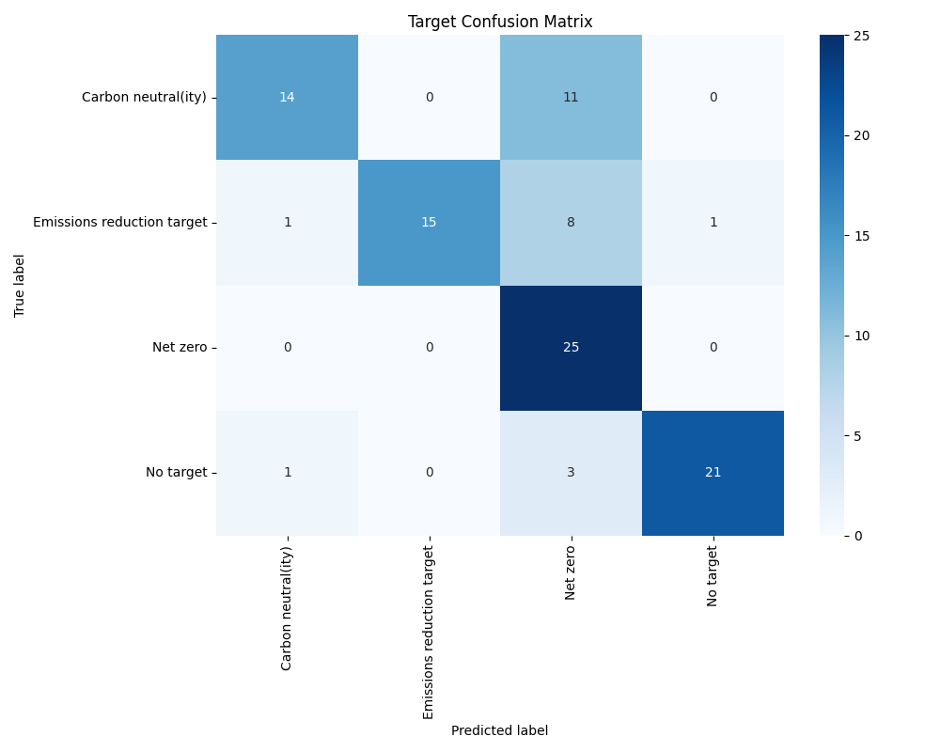

Year Confusion Matrix:

